**Registry Editor**

**Accessing the Registry**

**Type regedit in Start**→**Search**

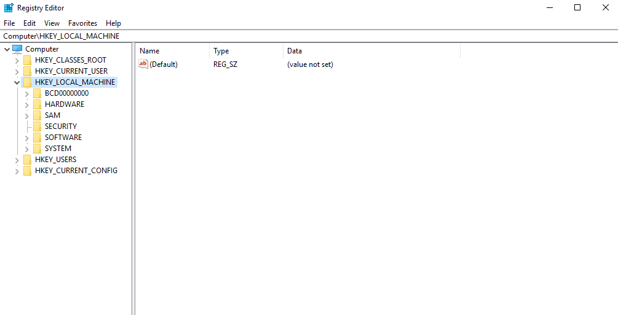

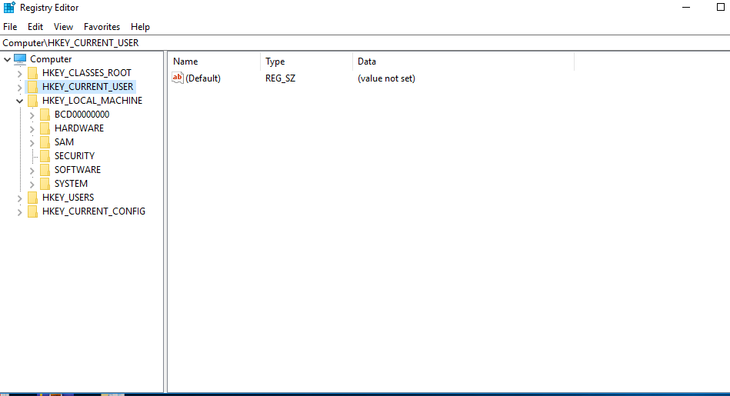

**Wireless Evidence in the Registry**

**HKEY_LOCAL_MACHINE\SOFTWARE\Microsoft\WindowsNT\CurrentVersion\NetworkList\Profiles**

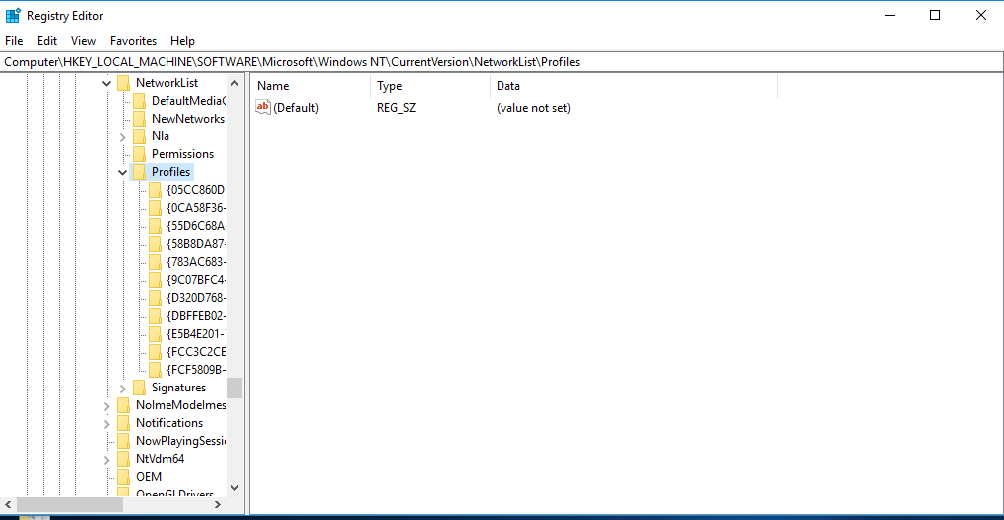

**The RecentDocs Key**

**HKEY_CURRENT_USER\Software\Microsoft\Windows\CurrentVersion\Explorer\RecentDocs**

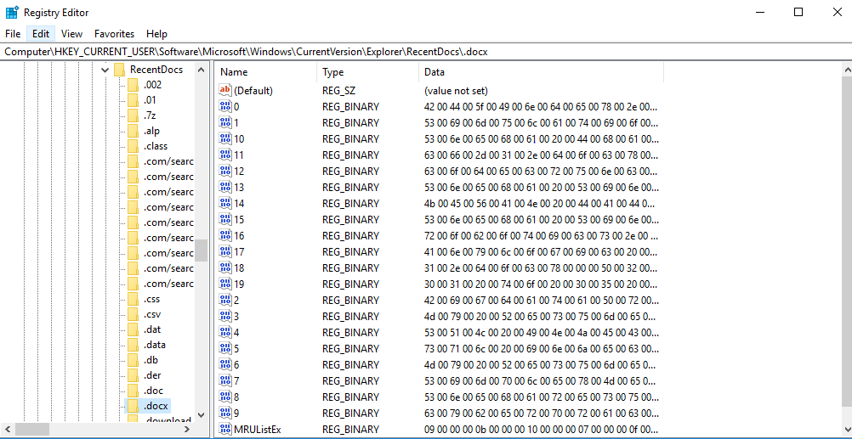

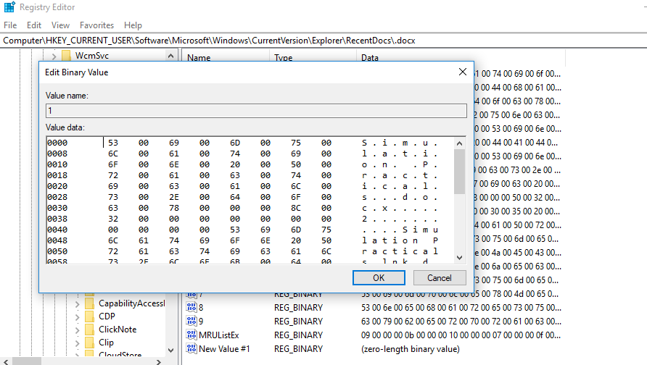

**TypedURLs Key**

**HKEY_CURRENT_USER\Software\Microsoft\Internet Explorer\TypedURLs**

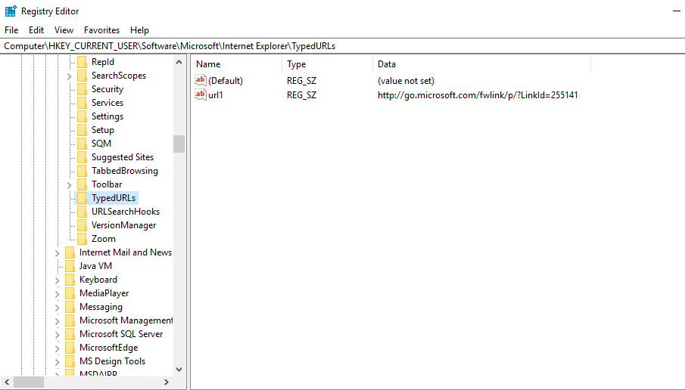

**Start Up Locations in the Registry**

**HKEY_LOCAL_MACHINE\Software\Microsoft\Windows\CurrentVersion\Run**

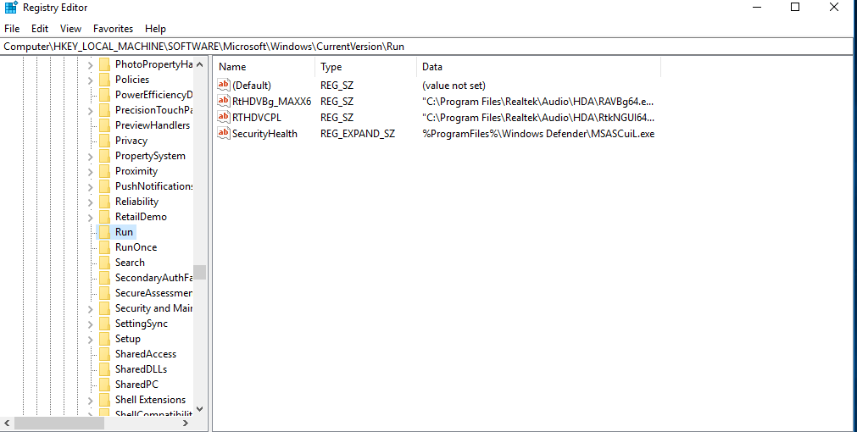

**RunOnce Startup**

**HKEY_LOCAL_MACHINE\Software\Microsoft\Windows\CurrentVersion\RunOnce**

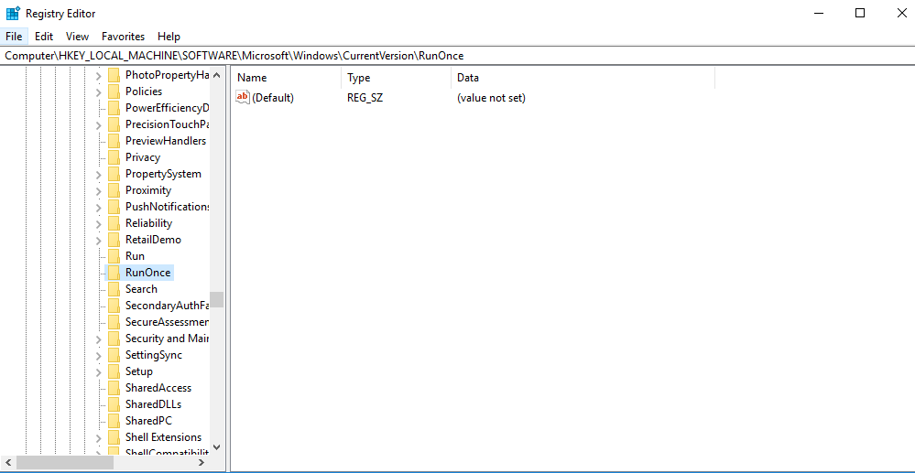

**Start Up Services**

**HKEY_LOCAL_MACHINE\System\CurrentControlSet\Services**

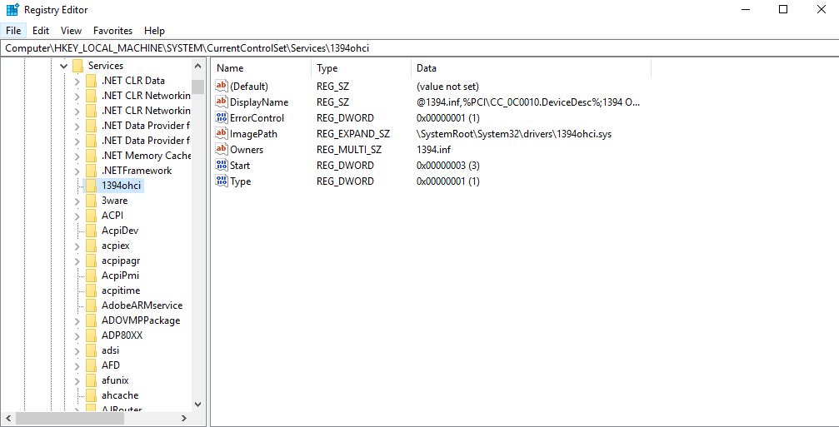

**Start Legacy Applications**

**HKEY_LOCAL_MACHINE\System\CurrentControlSet\Control\WDI**

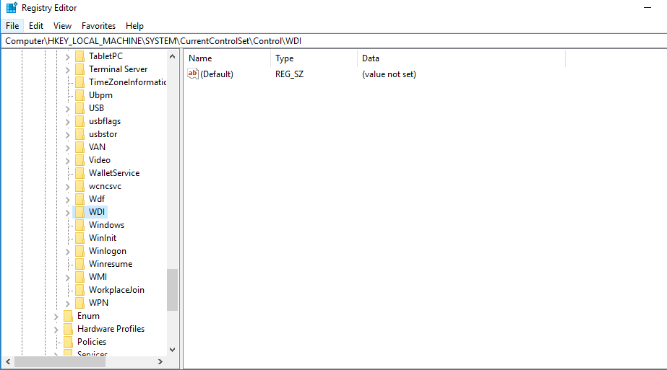

**Start When a Particular User Logs On**

**HKEY_CURRENT_USER\Software\Microsoft\Windows\CurrentVersion\Run**

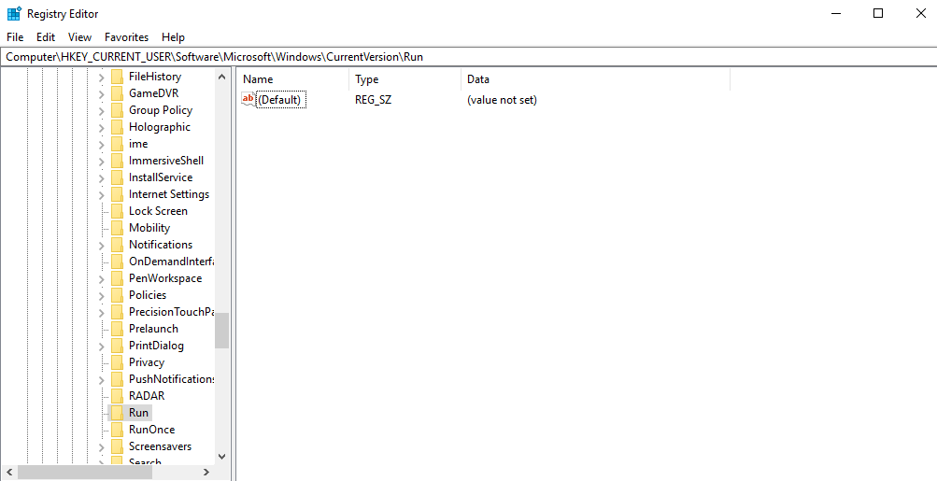

**USB Storage Devices**

**HK_Local_Machine\System\ControlSet00x\Enum\USBSTOR**

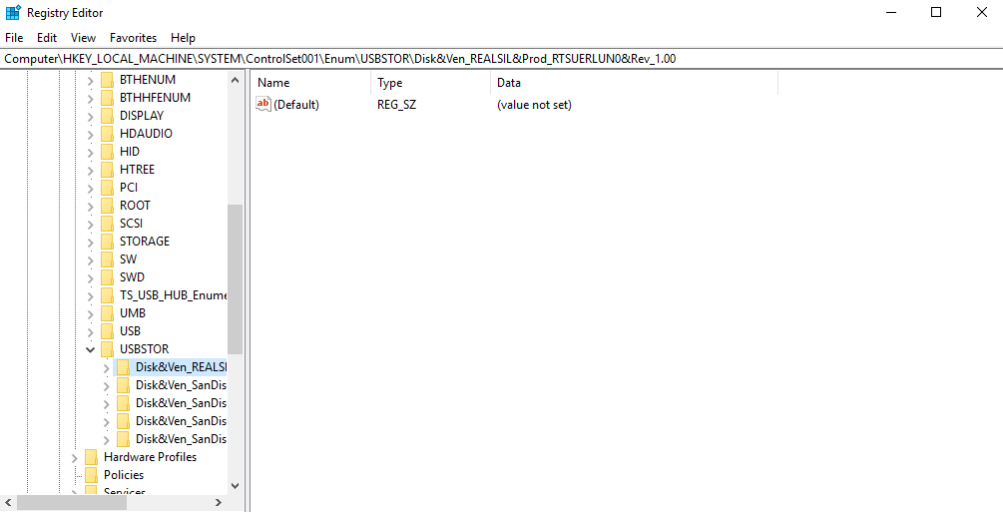

**Mounted Devices**

**HKEY_LOCAL_MACHINE\System\MountedDevices**

